OUTPUT:
Generating Heston and Merton path plots...
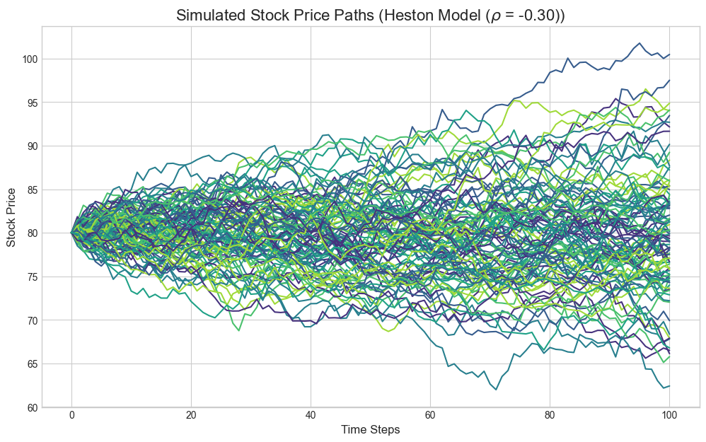
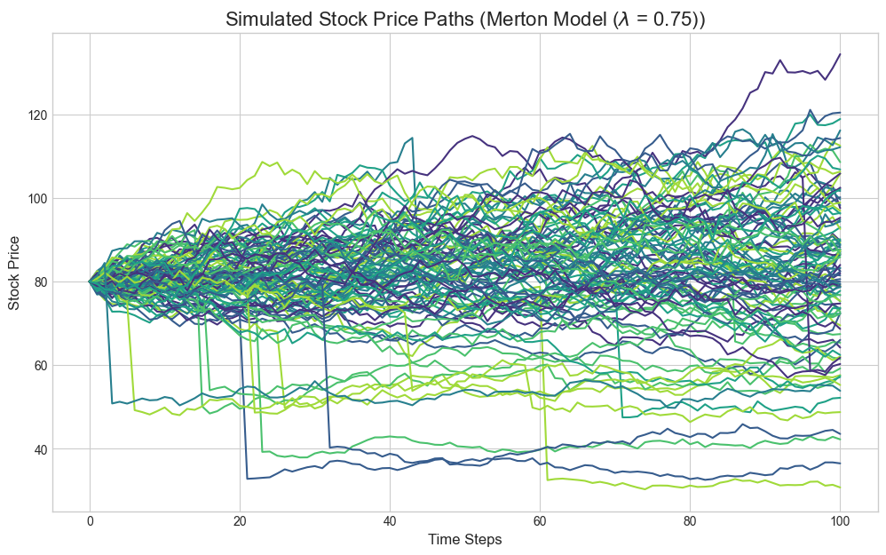
Generating Call Price vs. Moneyness plot...
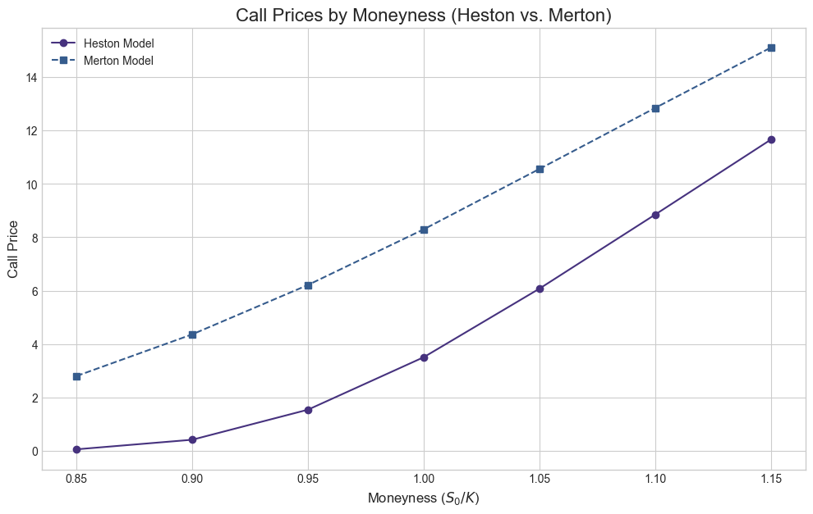
Generating Greek vs. Stock Price plots for Heston...
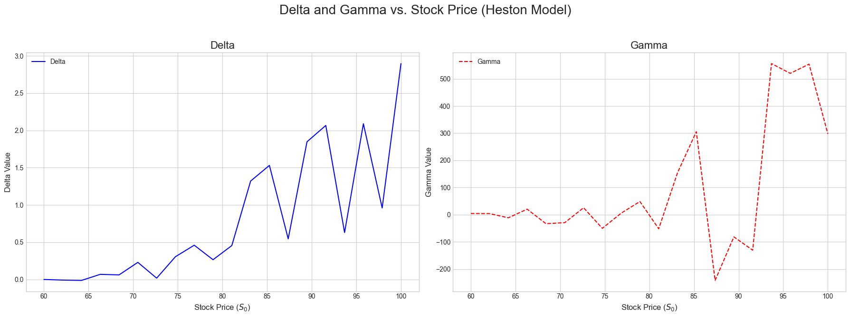
Generating Greek vs. Stock Price plots for Merton...
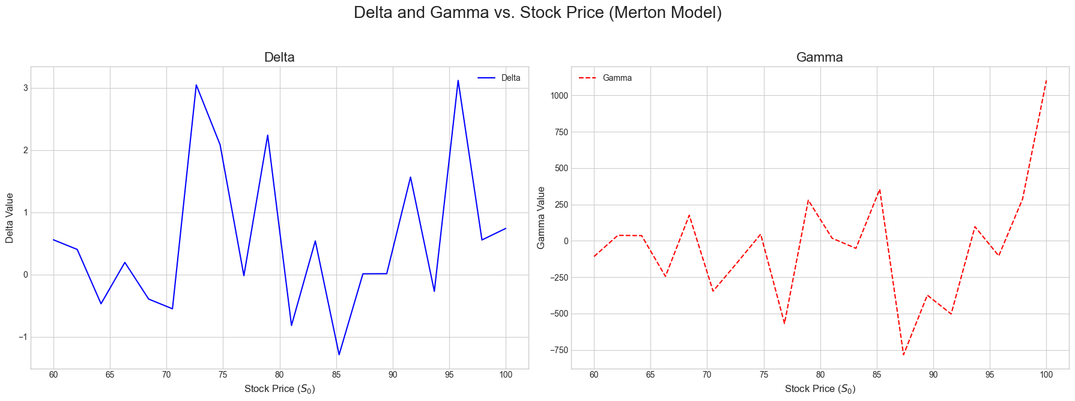

All calculations and plots have been generated.
--- Technical Report Data ---
Calculations completed at: 2025-08-20 19:08:04

### Heston Model Results (Q5, Q6, Q7)
| Question | Correlation (ρ) | European Call Price | European Put Price |
|-----------:|------------------:|----------------------:|---------------------:|
| 5 | -0.3 | 3.49 | 2.39 |
| 6 | -0.7 | 3.52 | 2.41 |

| Question | Call Delta | Call Gamma | Put Delta | Put Gamma |
|:------------|-------------:|-------------:|------------:|------------:|
| 7 (ρ=-0.30) | 1.04 | -342.93 | -0.81 | 15.25 |
| 7 (ρ=-0.70) | 0.56 | -199.82 | -0.82 | 23.79 |

---

### Merton Model Results (Q8, Q9, Q10)
| Question | Jump Intensity (λ) | European Call Price | European Put Price |
|-----------:|---------------------:|----------------------:|---------------------:|
| 8 | 0.75 | 8.29 | 7.23 |
| 9 | 0.25 | 6.8 | 5.73 |

| Question | Call Delta | Call Gamma | Put Delta | Put Gamma |
|:------------|-------------:|-------------:|------------:|------------:|
| 10 (λ=0.75) | -0.89 | -1405.4 | -1.1 | 701.94 |
| 10 (λ=0.25) | 1.37 | -181.25 | 1.98 | 577.28 |

---

### Put-Call Parity Check (Q11)
| Model | C - P (Actual) | S0 - K*exp(-rT) (Theory) |
|:-----------------|-----------------:|---------------------------:|
| Heston (ρ=-0.30) | 1.1 | 1.09 |
| Heston (ρ=-0.70) | 1.11 | 1.09 |
| Merton (λ=0.75) | 1.06 | 1.09 |
| Merton (λ=0.25) | 1.07 | 1.09 |

---

### Call Prices by Moneyness (Q12)
| Moneyness (K) | Heston Call Price | Merton Call Price |
|----------------:|--------------------:|--------------------:|
| 94.1176 | 0.06 | 2.8 |
| 88.8889 | 0.41 | 4.36 |
| 84.2105 | 1.54 | 6.21 |
| 80 | 3.5 | 8.3 |
| 76.1905 | 6.07 | 10.56 |
| 72.7273 | 8.85 | 12.84 |
| 69.5652 | 11.66 | 15.1 |

---

### American vs. European Call and Greeks (Q13)
| Option Type | Price | Delta | Gamma |
|:--------------|--------:|--------:|--------:|
| European Call | 3.48 | 0.79 | -7.28 |
| American Call | 3.45 | 0.37 | -118.35 |

---

### European Up-and-In Call (Q14)
| Option Type | Model | Strike | Barrier | Price |
|:------------------------|:--------|---------:|:----------|--------:|
| European Vanilla Call | Heston | 95 | N/A | 0.04 |
| European Up-and-In Call | Heston | 95 | 95.0 | 1.37 |

---

### European Down-and-In Put (Q15)
| Option Type | Model | Strike | Barrier | Price |
|:-------------------------|:--------|---------:|:----------|--------:|
| European Vanilla Put | Merton | 65 | N/A | 2.76 |
| European Down-and-In Put | Merton | 65 | 65.0 | 10.77 |

---

